________________________________________________________________________

Underwriting Module

User Manual version 1.0

Document Control

- Document History

Version | Date | Status  (Draft /Final) | Author | Comment / Changes from Prior Version
1.0 | 31-Jan-08 | Draft | Asaithambi | User Manual Initial Version
 | March 2008 | Final

- Document Reviewers/Approvers

Name | Position (e.g. Client Manager, Project Manager etc.) | Reviewer (only) | Reviewer and Approver

Table of Contents

Main Menu 3
Administration Main Menu 3
User Administration Menu 4

Main Menu

Screen 1

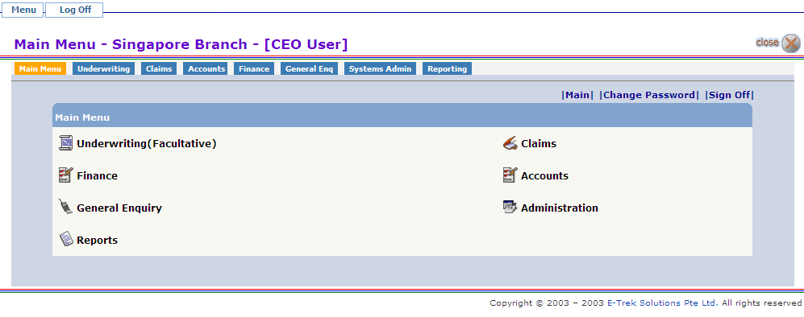

Click on the Administration to go into Administration Main Menu.

Administration Main Menu

Screen 2

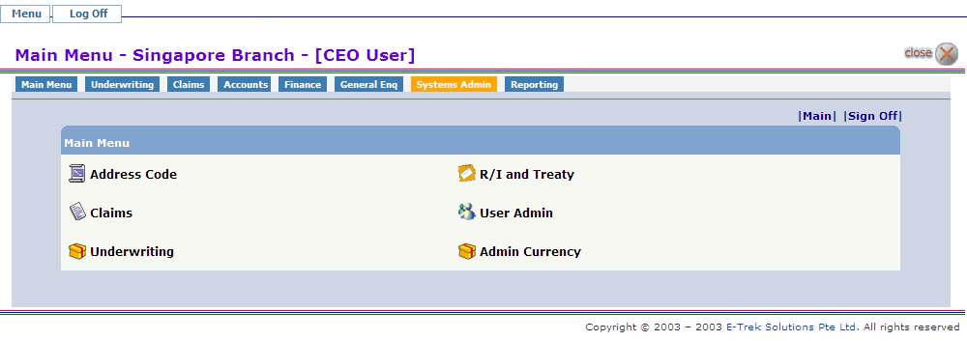

Click on User Admin to go into User Administration Menu.

User Administration Menu

The creation of New User, Access Rights, Authority Limits and Branch accessibility is in this flow –

ENTITY → USER GROUP → DEPARTMENT MASTER -> USER

LIMITS BRANCH

Screen 3

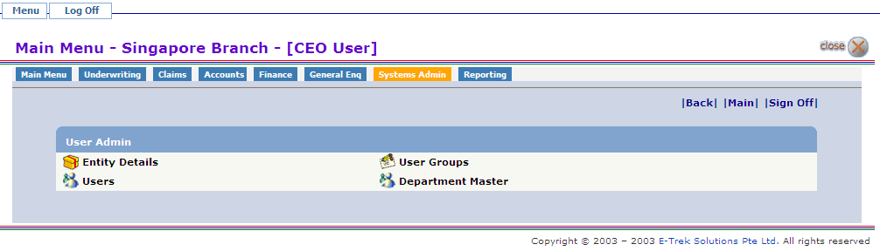
The above screen show all the Admin Table related to User Admin Module. Click on the link that will take you to the corresponding page.

Creating/Searching/Editing/Viewing Entity Details Master

Screen 4

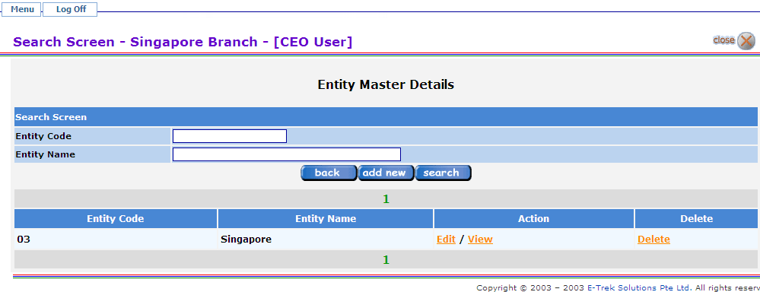
Click on the button to go to previous page.

Click on the button to get all Entity list from the Entity Master. User can search by Entity code and Entity Name.

Click the Edit link to edit the Entity Details.
Click the View link to view the Entity Details.
Click the Delete link to delete the Entity Details.

Click on the button to add a New Entity Details.

Screen 4.1

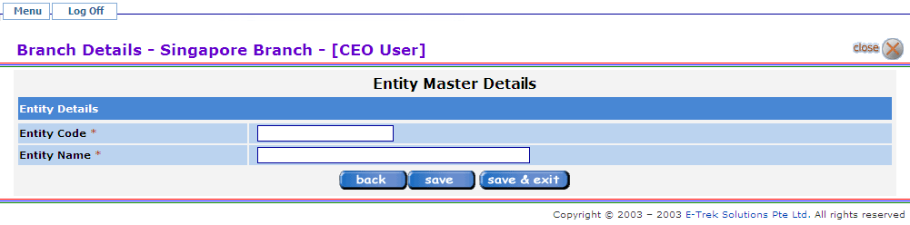
Fields marked * are mandatory fields.

Click on the to Save/Update the Entity Master Details.

Click on the to Save/Update the Entity Master Details and go to previous page.

Creating/Searching/Editing/Viewing User Group Master
Screen 5

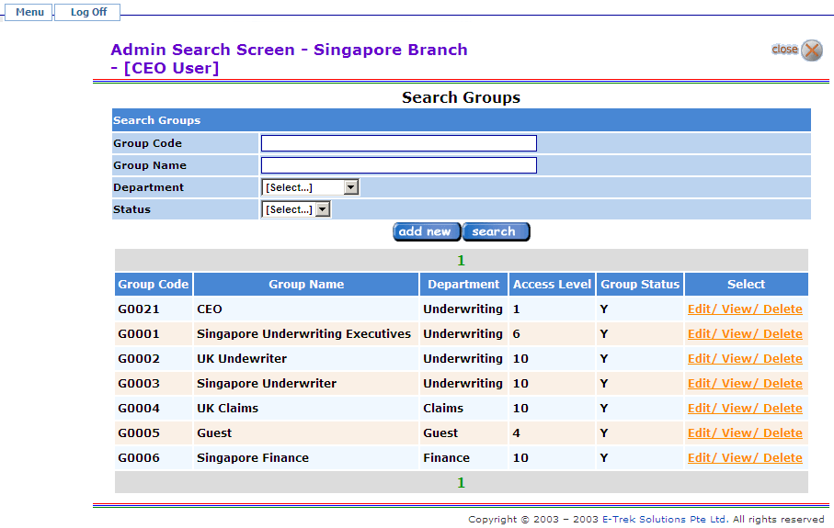

Click on the button to get all User Group list from the User Group Master. User can search by Group code, Group Name, Department and Status.

Click the Edit link to edit the User Group Details.
Click the View link to view the User Group Details.
Click the Delete link to delete the User Group Details.

Click on the button to add a New User Group Details.

Screen 5.1

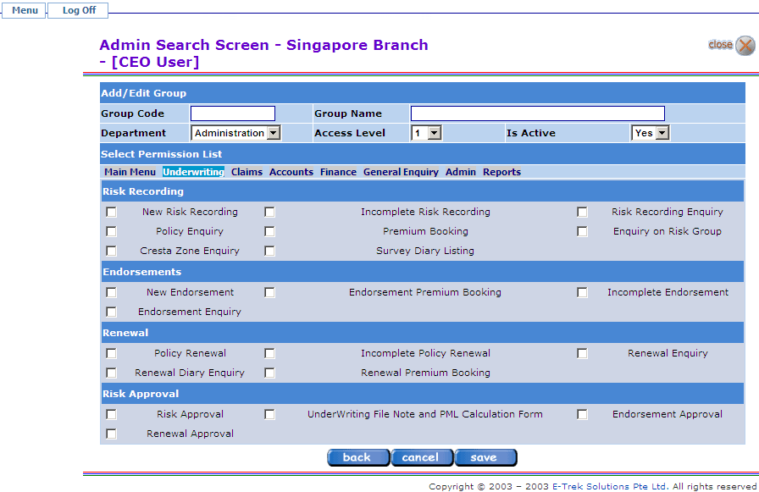

Click on the to Save/Update the User Group Details.

Click on the or button to go to previous page.

Creating/Searching/Editing/Viewing Department Master
Screen 6

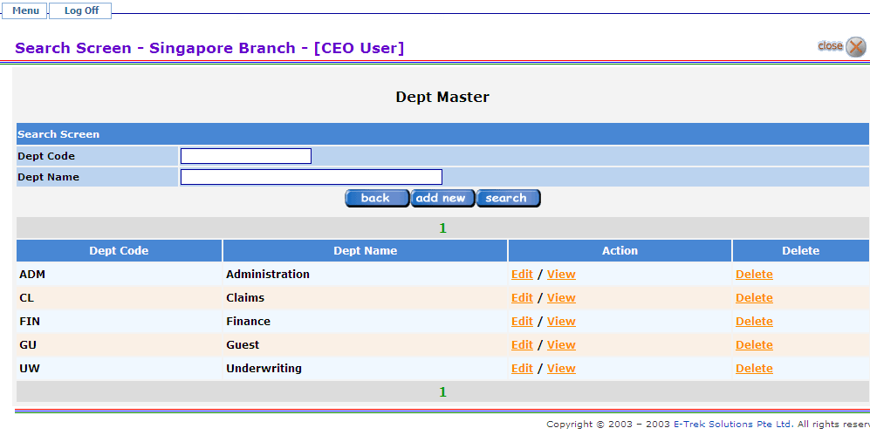

Click on the button to go to previous page.

Click on the button to get all Department list from the User Group Master. User can search by Department code and Department Name,

Click the Edit link to edit the Department Details.
Click the View link to view the Department Details.
Click the Delete link to delete the Department Details.

Click on the button to add a New Department Details.

Screen 6.1

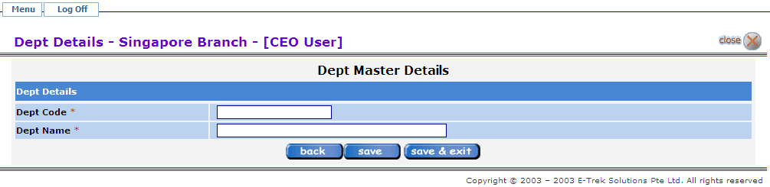

Fields marked * are mandatory fields.

Click on the to Save/Update the Dept master Details

Click on the to Save/Update the Dept Master Details and go to previous page.

Creating/Searching/Editing/Viewing User Master
Screen 7

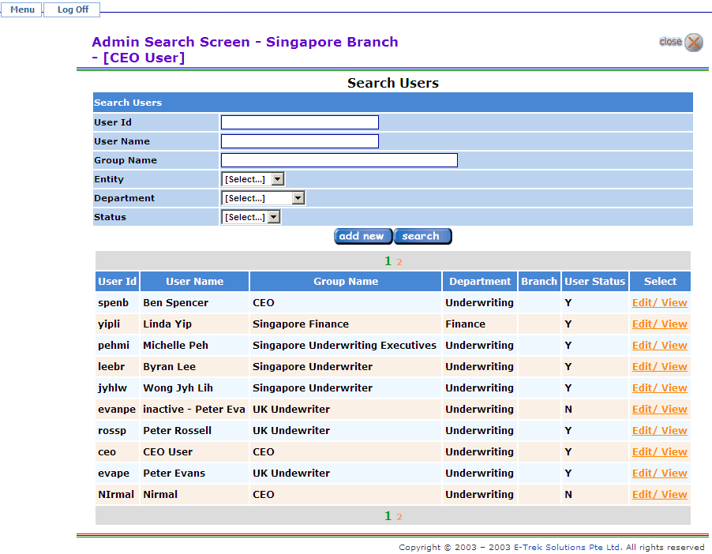
Click on the button to get all User list from the User Master. User can search by User Id, User Name, Group Name, Entity, Department and Status.

Click the Edit link to edit the User Details.
Click the View link to view the User Details.

Click on the button to add a New User Details.
Screen 7.1

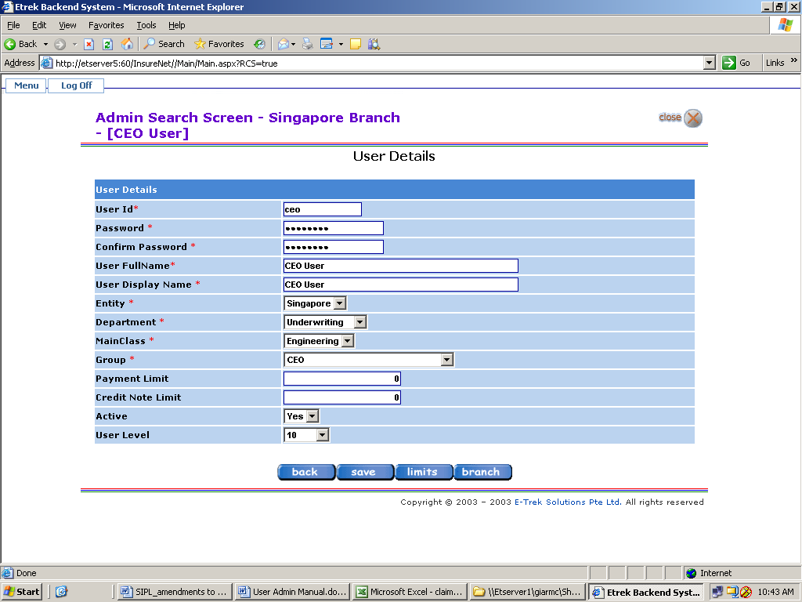
Fields marked * are mandatory fields.

User ID | 20 alphanumeric chars.  If first char is alphabet, then the field accepts alphanumeric chars  If first char is numeric, then, the field will accept only numeric chars
User Password | 10 alphanumeric
User Full name | 100 chars
User Display Name | 20 chars
User Level | Range from 1 to 10, with level 1 being lowest

For first time creation of User, Administrator creates the User ID and Password. When new User first log into system, User will be required to change the Password.

If a User is no longer allowed to access the system, change Active field to “No”

Click on the to Save/Update the User Details. Additional buttons will be displayed to complete “Limits” and “Branch”.

Click on Limits and the following screen will appear -

Screen 7.2

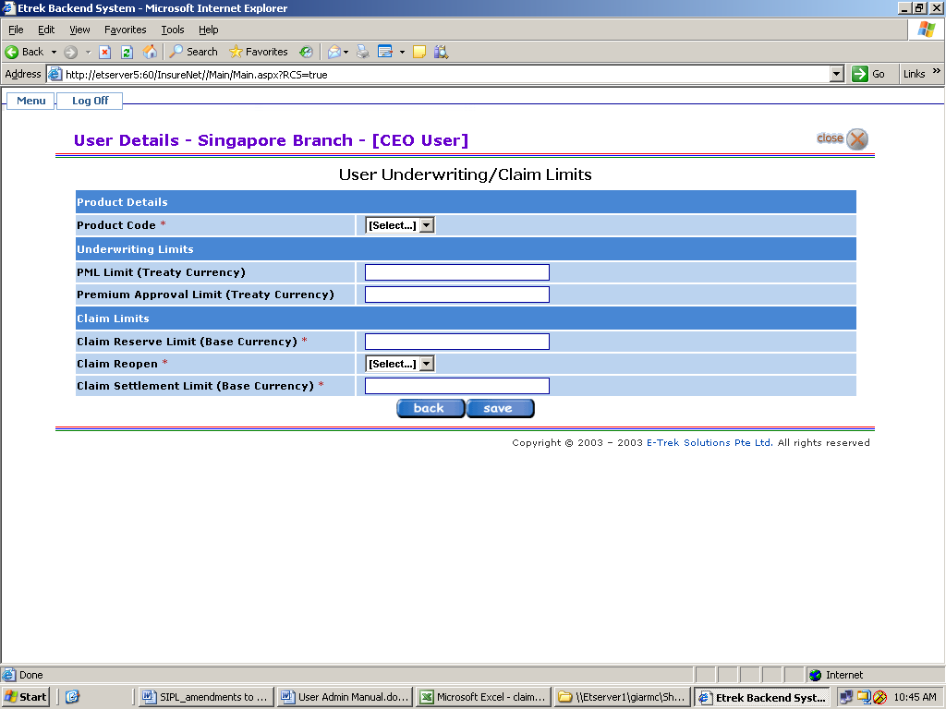

Complete the details by clicking on and the following screen will be displayed.

Screen 7.2.1

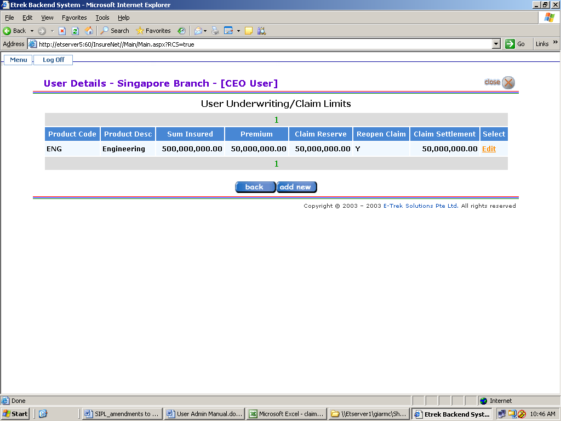

The limit can be edited or if limits are to be set for another Product Code, click on .

Once done, go back to the User creation screen 6.1 and click on “Branch”. The following screen will appear -

Screen 7.3

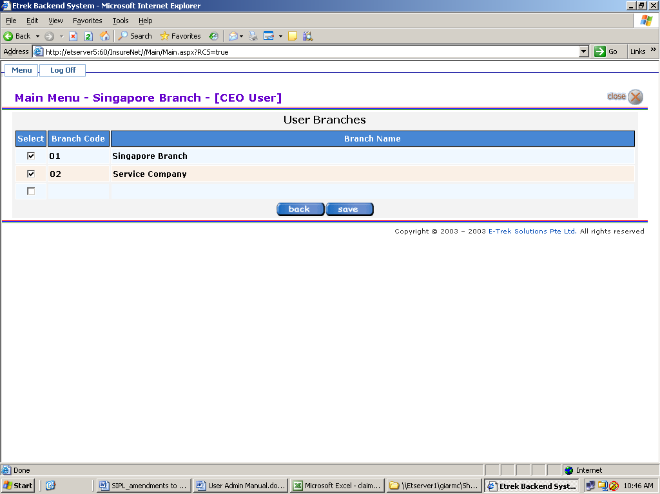

Select the Branch that User is authorised to access. Once done click on to update details.

Click on the button to go to previous page and back to Screen 6.1.

PLEASE CLICK ON AGAIN TO SAVE AND UPDATE ALL DETAILS CREATED.

